Transnational meeting in Hungary (29th november. – 3rd december 2015)
READ in Europe
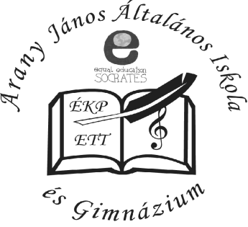
 | Activities | Location | Fees and expenses
Sunday,  November  29th | Arrivals:  - Croatia:22.00  - Italy: 14:20  - Lithuania:18:05  - Spain: 16:55  - Turkey: 08:20 |  | transfer from the airport to Százhalombatta
Monday,  November 30 | 9.00 Welcome to Arany János school  Introduction, Tour of school  - presentation of schools, presentation of students, presentations of our towns  - revision of timeline and project activities, assigning roles and duties, agreement on dates of mobilities of first project year  - agreeing on common tools for project management and dissemination  - questionnaire: choosing the common way of presenting our questionnaire findings in the form of diagrams  13.00: lunch  - preparation of 1st student exchange and teacher training  - logo competition: rules  1 18.00 : common free time activity  dinner | Százhalombatta | lunch: 2500 ft / person  dinner:
Tuesday  December 1st | 9.00-12.45 : discussions and workshops  Workshops:  ICT tools for project activities: student cooperation, teaching handbook  Teachmeet: sharing tools  curriculum for non-formal learning  Using European Language Portfolio  13.00: lunch in Ebatta  16.00 - 19.00 : drama workshops: team building activities  Dinner | School | Lunch: 2500 ft / person  dinner:
Wednesday  December 2nd | Trip to Budapest  Turkish colleagues: departure at 20.15 | Budapest | Bus to Budapest  Admission fee?  lunch:  dinner
Thursday,  December 3rd | Leaving Százhalombatta:  Croatia: 8:00  Italy: 10:15  Lithuania:8:00  Spain:10:10 |  | transfer to the airport

