Sunday  April 10th | Monday  April 11th | Tuesday  April 12th | Wednesday  April 13th | Thursday  April 14th | Friday  April 15th | Saturday  April 16th
A  R  R  I  V  A  L  S  20:00  Dinner | 9:00  Welcome meeting and school tour  10:15:  Interactive city tour  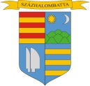  11:30  Visit to local library  12:30  Lunch  14:00  Visit to Archeological Park  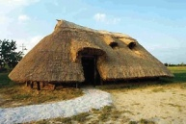  19:00  Dinner | Visit to Danube Bend  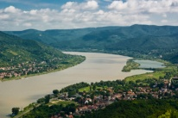  8:30  Departure  10:30  Visit to Royal Castle  12:00  Visit to Salamon Tower and tournament  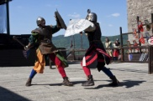  14:15  Renaissance lunch  16:00  Visit to Szentendre  19:00  Dinner | 8:00 – 9:45  Visiting lessons  10:00-13:00  Drama workshop  13:15 - Lunch  14:00- 16:00  Workshop on reader part 1  18:30  Dinner | Visit to Budapest  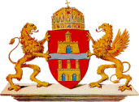  9:00 – 13:00  Visit to Széchenyi National Library and sightseeing tour  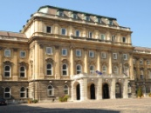  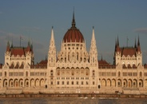  Free time and shopping  19:00  Dinner at Ebatta | 8:00-10:45  Workshops and discussions about the EU  11:00 – 13:00  Workshop on reader part 2  13:00  Lunch  17:30 – 19:30  Intercultural farewell party  20:00  Dinner | D  E  P  A  R  T  U  R  E  S

