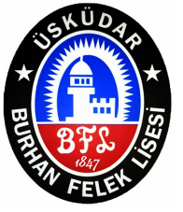
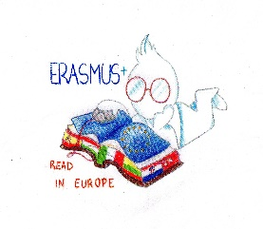
Burhan Felek Anadolu Lisesi
Erasmus+

Transnational Meeting in Istanbul, Turkey
5 – 8 September 2017

Date | Activities
Tuesday September 5th | Arrivals 20:00 Dinner at ModaTeras Restaurant
Wednesday September 6th | 9:00  - Welcome speech and introduction by the headmaster  - To prepare activities for the third year  - Deciding on mobility date for Italy  - Assingning roles and duties | - 13:00 Lunch at Maruf Cafe | - 14:30 Keeping on the meeting  - 15:30 Brain storm on a story and a poem “literary text” workshop  - 17:00 Kadıköy tour | - 20:00 Dinner at Kalamış Midpoint Restaurant
Thursday September 7th | - 9:00-9:30 Meeting with National Education Directorate  - 10:30 Meeting with the Mayor of Üsküdar | - 11:30 Bosphorus Tour  - 13:00 Lunch near the school | - 15:00 Üsküdar/Salacak tour  - 16:00 Free time | - 19:00 Dinner at Anadolu Kavağı
Friday September 8th | - 9:00 Historical Peninsula Tour ( Hagia Sophia, Blue Mosque, Topkapı Palace, Basilica Cistern)  - 12:00 Visiting Tanpınar Library (A Turkish Writer) | - 13:00 Lunch at Sirkeci Hayal Kahvesi | - 14:30 Galata Tower, Galata Mevlevihanesi (Lodge Used by Mevlevi Dervishes), Innocent Museum (Orhan Pamuk’s Literature Museum)  - 17:00 Visiting a Writer’s Workshop in Galata (with Turkish Novelist and Story Writer Jale Sancak)  - 18:30 Coffee Break in Karaköy | - 20:00 Dinner at Galata Konak Restaurant
Saturday September 9th | DEPARTURE

